**The 2G Lab**

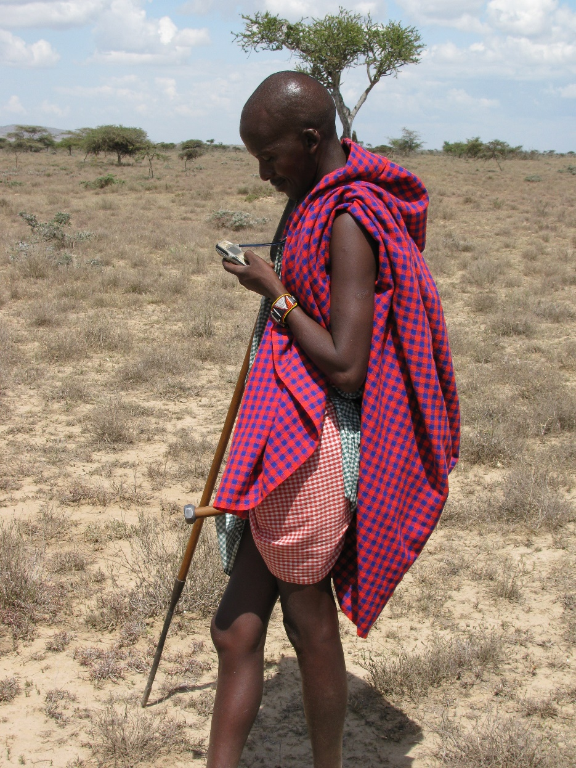

Figure 1 - Masai with Cell Phone

**The Problem?**

1. Working with technology in the sometimes-connected developing world is different and hard
2. Only 40% of the developing world has a mobile internet connection; less than 40% have smartphones
3. The design constraints for technology in the developing world are significant
4. The digital divide persists for the foreseeable future

**The What & How?**

1. Dial-a-context telecommunications environment
2. Simulate crisis scenario for voice and data
3. Immersion experience: problem solving in a bi-modal crises simulation
4. Test apps and systems in constrained environments
5. The UL for fit-for-purpose developing country apps

**Benefits?**

1. Sensitize entrepreneurs for relevant design
2. Learn how to work with technology in crises
3. A test-bed for lightweight apps and devices

**How to get involved?**

1. Sign up for Crisis Informatics course in the fall
2. Join Advisory Committee for Crisis Informatics (ACCI)
3. Contact Ed Happ at [ehapp@umich.edu](mailto:ehapp@umich.edu)



Figure 2- GSMA Intelligence Report

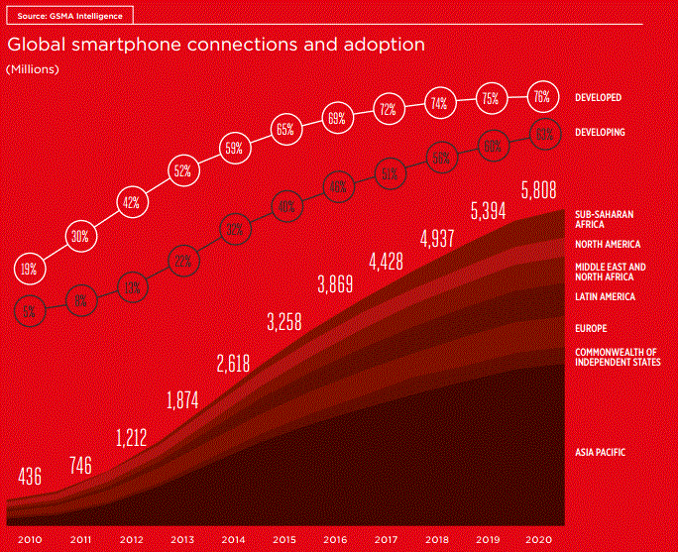

Figure 3- GSMA Intelligence Report ii

*How do we solve problems and build apps in a 2G world?*

*The numbers are 66% and 65% for the Developed World; the gap is narrowing, but not much…*

*Welcome to the Digital Divide*